** Christianity around the Sea of Galilee**  and other sites from Bronze age until Islamic period

**Monday, January 30, 2023:**

**A study seminar** **of tours and lectures for tour guides with**

**Yisca Harani and Dr. Georg Röwekamp**

|  |
| --- |
|  |

**The seminar will be based in the Pilgrim House of Tabgha**

**Program:**

Monday, January 30:

9:30 h Arrival to Pilgerhaus Tabgha. Registration

(Arrive on your own, there will be no arranged transportation)

10.00 h         Tour to Khirbet al-Minya and Tel Kinrot (G.R. / Y.H.)

12.30 h Tour the Church of the multiplication, Beit Noah, Dalmanuta and the

surroundings (G.R. / Y.H.).

Picnic lunch on your own

16.00 h         Lecture: “The History of the Holy Land in a nutshell: introducing the new   
 mini museum at Pilgerhaus Tabgha (G.R.)

17:15 h Lecture: Introduction to the Christian/Benedictine Liturgy of the Hours -

With special consideration of its Jewish Origins” (G.R. / Y.H.)

18.00 h Possibility to join the Evening Prayer / Vespers in the Church of the

Multiplication

19.00 h          Dinner (bring your own or reserve by prepayment in the Pilgerhous)

20.15 h Lecture: Reading the Miracles in Biblical context (Y.H.)

* **Price of the study day, including the new Tabgha booklet – 150 NIS** 100 NIS through this link <https://www.yiscaharani.com/event-details/> and 50 in cash on site. * The price does not include transportation. Arrive and travel in private vehicles (try to join cars).

* The study day does not count for the Ministry of tourism license renewal.   
* Bring your own food for the day. Free coffee, tea and cookies will be available. * You can order dinner for 50 shekels in the Pilgerhouse   
* The program is "eat as much as you can"… there is plenty to see, hear and learn. You can choose to leave earlier but be mindful of the late ending of the program.

**­­See you in Tabgha!**

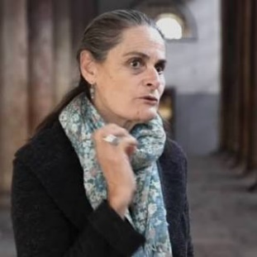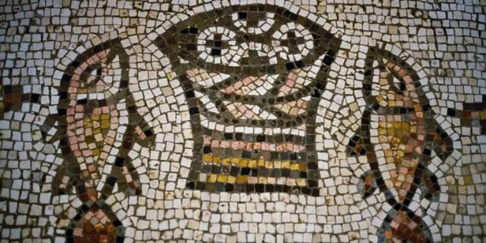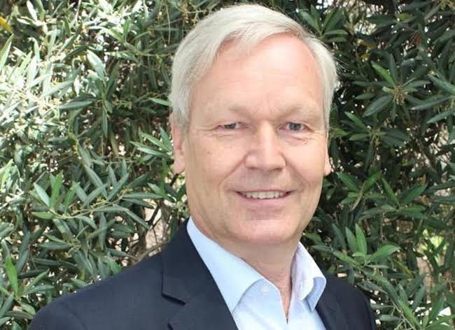

* Pilgerhaus Tabgha offers a reduced rate for participants who want to stay in the guesthouse:

450 Shekels per person in a double room including dinner and breakfast,

600 Shekels per person in a single room including dinner and breakfast

Registration form to Pilgerhous Tabgha: Please fill in the following details for registration and payment, and send to [pilgerhaus-tabgha@dvhl.de](mailto:pilgerhaus-tabgha@dvhl.de)

|  |  |  |  |
| --- | --- | --- | --- |
| **First name** | **Family name** | **ID number** | **Tour guide license** |
|  |  |  | **1.** |
|  |  |  | **2.** |
| **email addresses (mandatory)** | | **Telephone numbers (mandatory)** | |
|  | | **1.** | |
|  | | **2.** | |

**Price for 2 participants in a double room HB**

|  |  |  |
| --- | --- | --- |
| Please charge my credit card in the amount of NIS XX for a couple (price for tour guides), in a double room for the entire seminar. Please note: in all rooms the beds are separate. | | |
| **validity** | **Credit card number** | **Credit card** |
|  |  |  |

**Price for 1 participant in a room HB**

|  |  |  |  |
| --- | --- | --- | --- |
| Please charge my credit card in the amount of NIS xx for a single participant (price for guides) for the entire seminar. | | | |
| **validity** | **Credit card number** | **Credit card** | |
|  |  |  |  |

